**Z`How to Erase and Reformat a USB Drive Using Disk Utility on MacOS**

Introduction

Formatting a USB drive on MacOS is an essential task when it comes to erasing data or preparing the drive for use across various devices. Unlike on Windows, formatting USB on MacBook will be a bit more complicated that requires an intuitive tool called Disk Utility. This instruction provides the process of erasing and reformatting a USB drive is completed safely and efficiently for MacBook users.

Definitions

* Disk Utility: a hard drive management application built into MacOS, commonly used to monitor hard drive parameters, repair hard drives, modify file and folder permissions, or reformat USB or hard drives.
* Format USB: convert formats, delete data, fix errors, and return USB to normal state.

Caution before performing operations

Before formatting the USB on the computer, backing up data is extremely important because the USB will be restored to its original state, the data will be completely deleted after formatting is complete. After formatting the USB, check the USB again, make sure the displayed capacity is correct with the USB capacity, the ability to write and read data is normal, and no malicious files appear.

Directions:

1. Plug USB into computer.
2. Open Spotlight via Command + Space.
3. Type “Disk Utility” into the Search box and press Enter to access the application.

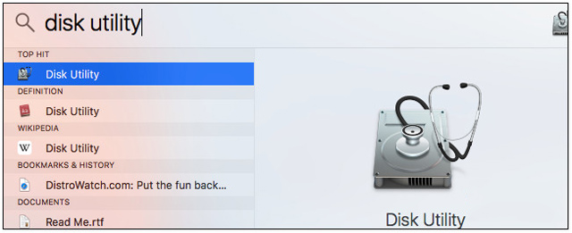

Figure Alternatively, another way to access this application is to go to Finder > Applications > Utilities > Disk Utility.

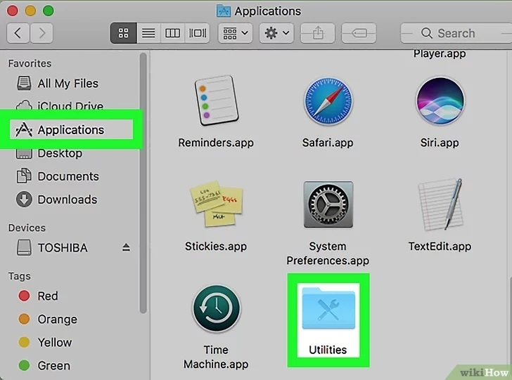

Figure

1. The Disk Utility window will appear. In the list on the left, find and click on the name of the USB drive that needs to be formatted, in this case the TOSHIBA drive.

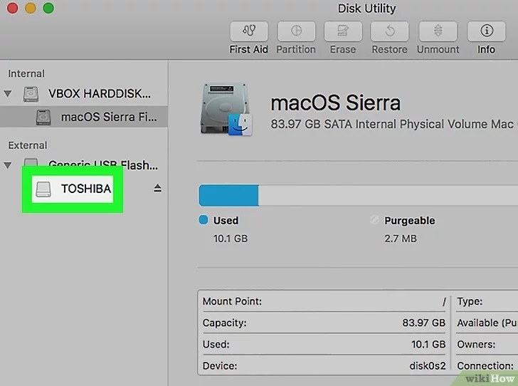

Figure

1. Select “erase” to format the USB and create a new partition.

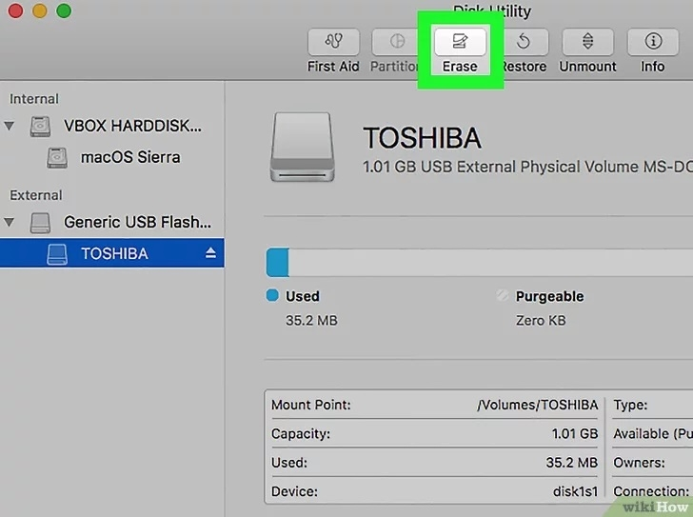

Figure

1. The Nane field: is used to give the drive a different name or can be kept as is.

* The Format field: can be used to select exFAT, FAT32, or Mac OS Extended (Journaled) format.

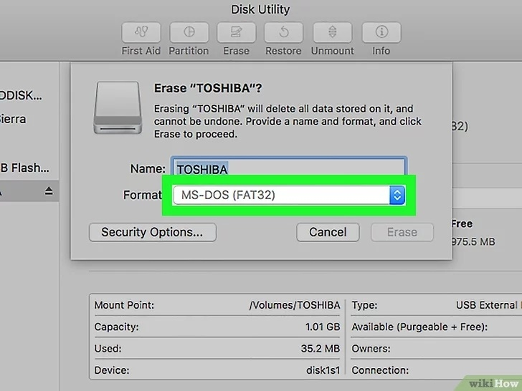

Figure

In addition, the partition format (Format) can be selected, including:

* **OS X Extended (Journaled)**: Also known as HFS+, this is the default file system format on Mac. To back up a MacBook with Time Machine, this format is recommended; otherwise, exFAT is a suitable alternative.
* **OS X Extended (Case-sensitive, Journaled)**: This format distinguishes between uppercase and lowercase letters in folder names. For example, "File" is treated differently from "file."
* **OS X Extended (Journaled, Encrypted)**: Similar to the OS X Extended (Journaled) format, but with encryption, requiring a password each time the USB drive is connected to a MacBook.
* **OS X Extended (Case-sensitive, Journaled, Encrypted)**: This format distinguishes uppercase and lowercase letters in folder names and also includes encryption.
* **MS-DOS (FAT)**: A widely used format across operating systems, including Mac, Windows, and Linux, though it has a file size limit of around 4GB.
* **ExFAT**: A cross-platform file system similar to the old FAT system, but without the file size limitations.
  + For external hard drives, formatting as ExFAT is generally recommended, unless the drive will be used for Time Machine backups.

1. After completing the customization process, click the Erase button to format and reformat the USB.

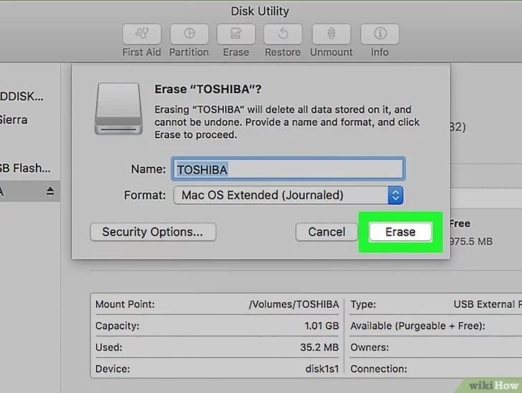

Figure

1. Wait until the formatting process is complete, then click Done.

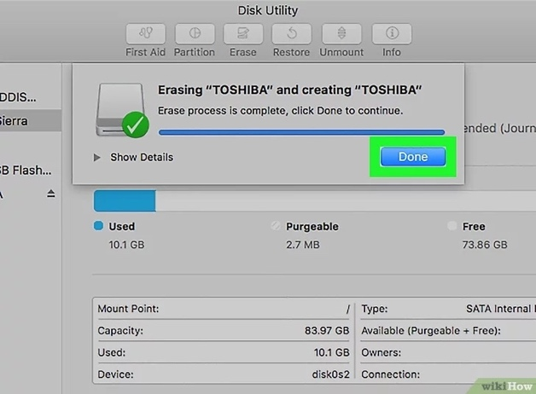

Figure

1. After formatting, removing the USB from the computer by right-clicking on the USB drive icon in Finder and selecting Eject.

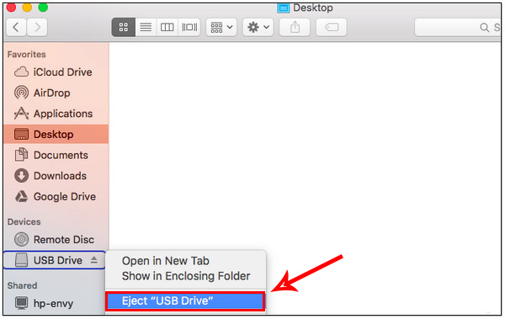

Figure

1. Check usb drive format: Plug in your USB drive and then go to Finder. Find and right-click on the USB drive icon in the sidebar of the Finder window, and select Get Info.

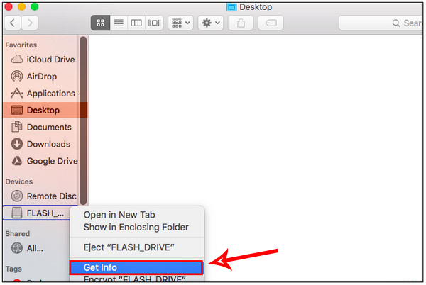

Figure

Figure The USB format will appear under Format. The image shows that this USB is formatted as exFAT.

Conclusion

Erasing and formatting a USB drive on MacOS using Disk Utility is simple when the steps are followed carefully. By completing the process, the USB drive can be set up for different tasks, like cross-platform use or backing up with Time Machine. It is important to choose the right format for the drive and always back up any important files before formatting to avoid losing data. This way, the USB drive will be ready for use with no issues.